Soil Investigation
Soils
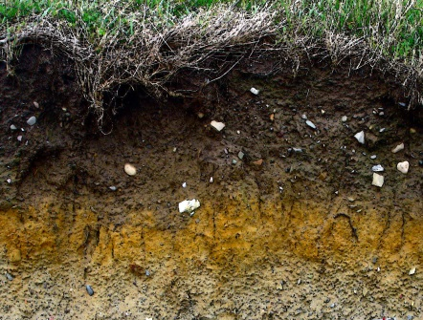
Investigation of a site should be carried out prior to building on this will enable us to identify information about our soil. Soil on site below ground level is checked. There are a wide range of soil types below the ground and we need to discover what layers we have and how deep they are… some soils are good at supporting load other are not. By carrying out an investigation we gather more knowledge of our soil plus we can now determine if our soil is capable of withstanding the weight of a house.

Soil Investigation and why????
To establish the soil type and its characteristics.
Is the site suitable for the building being proposed?
Ensuring a suitable foundation is chosen for the planned building.

Before visiting a site you could have already established some history with the site in question to finding a clear picture of the site and more importantly its soil condition. Ordnance Survey maps, planning records, historical documents and other methods of info are readily available also talking to neighbours close the site could also unfold more info ensure you have some of these below

Geology of the area
Topography
Vegetation
Natural Drainage
Previous use of the land
Typical foundations being used close by

Other factors to be considered in and around your site include
Protected structures
Heritage buildings
is the site prone to flooding???
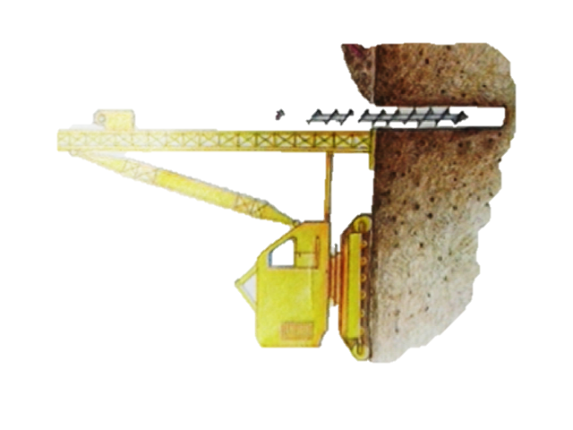
Are there overhead lines or underground services

A visit to the site is also worth gathering other such information like
The lie of the land
The nature of vegetation and plant growth
The feel of the soil (is it water logged)
Are there existing buildings
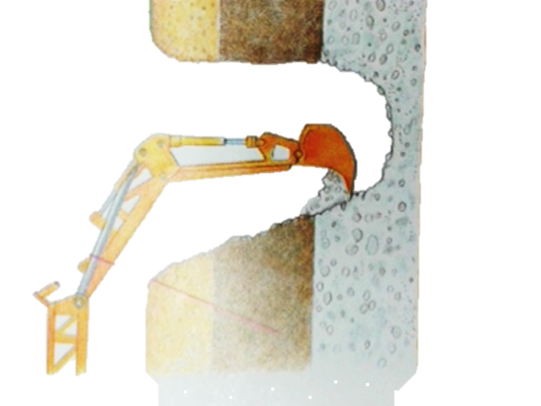
Any natural features (rock outcrop)

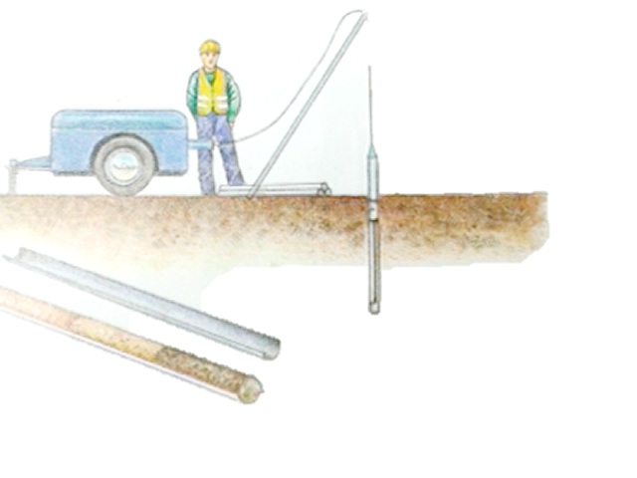
The final stage in any investigation is to carry out a soil analysis and determine the level of the water table. Traditionally investigations are carried out by digging trial holes. By digging a square pit with a mechanical digger a builder can better determine what type of soil is present. The same can be done with drilling hole with a huge auger the only disadvantage being all the soil comes out broken up. If poorer quality of soils is found first; say 3mtr deep then a sample tube is sent into the ground and a very accurate picture of the subsoil can be obtained. These readings and investigations can potentially give builders/architects a much better understanding of the load bearing capacity of the soil which is present on site, this is a huge finding as it will result in determining the use of an adequate foundation type being used to support the load of proposed dwelling.

Water Table
Due to different layers of soils, the ground therefore has differing ability to be able to soak or drain rainwater. This can be an important factor to be considered when planning to build. The water table can fall or rise throughout the year depending on the weather. Builders can experience problems related to the water table in two ways:
The subsoil can cause problems during the excavation of the foundations
A high water table can lead to flooding during consistent wet periods.

You can usual find a clue from the soil sample taken previously as to whether the soil can absorb moisture adequately.
Percolation Test
This involves looking at the rate at which the soil can absorb moisture this is particularly important if the dwelling is going to have its own waste water treatment system (septic tank).

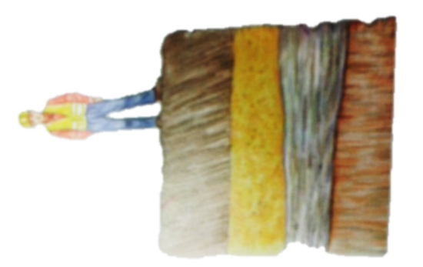
Soil Types
Soil types in Ireland are mainly categorised into 5 main groups and Rock. The five categories are Gravels, Sands, Silts, Clays and Peats. Amongst these five are two categories cohesive and non- cohesive. Cohesive soils will easily stretch and change shape (modelling clay) whilst non cohesive soils will crumble into small parts. The ability of a soil to carry a load is referred to as its Bearing Capacity. It is essential to know the bearing capacity of the soil on site before building as it will have a significant influence on the design of the house especially the foundations.

The upper part of soil is referred to as topsoil (300mm – 600mm) this surface is generally very soft and is usually scrapped back to allow marking out of the buildings exterior/interior walls.
