Important you read the following 2 Pages
150 Marks for Project & Portfolio in Total
Making of the Project = 60Marks
Portfolio = 90 Marks
25%
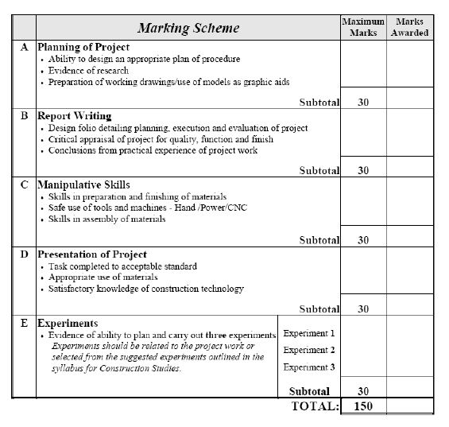

REMEMBER I MARK ALL WORK (see above) AND WANT TO GIVE YOU THE MAXIMUM GRADE POSSIBLE… HOWEVER IF WORK IS NOT ACCOUNTED FOR I AM NOT IN A POSITION TO AWARD YOU ANY MARKS!!!!
I WILL ACCEPT DIGITAL EMAILS OF YOUR WORK AS YOU PROGRESS…. THIS SHOULD BE FORWARDED TO MY SCHOOL EMAIL ADDRESS ckerrigan.bpp@lmetb.ie
Construction Studies Website should you need it:- http://bppcs.weebly.com/
This document has been compiled to help students understand the layout of their portfolios and additionally to give them a template to work from.
Ideally students should take a copy of this template and add to it (on a continuous basis) as they procede through-out their work. If students are in any doubt they should always refer to this document so as to closely monitor if all aspects of their work has been undertaken successfully as this document contains all relevant points in which student are ultimately marked on.
It is laid out in a fashion that includes all relevant headings; however the key point being students have to take ownership of all aspects of their work or this document becomes irrelevant.
All research and coloured freehand sketches have to be of students own undertaking, examiners do not like to see copy and paste articles from the internet they mark considerable high in areas where students have researched any area very well and have taken their own conclusions/interpretations from and used this information to move forward or create a better understanding.
If researched is found that is very useful you must acknowledge the source see example below ex newspaper article, magazine, TV programme, Visit to a site, Internet etc etc…..
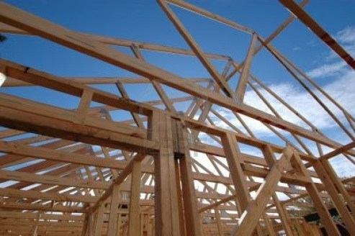

http://us.123rf.com/400wm/400/400/photoclicks/photoclicks0611/photoclicks061100047/633504-roof-frame-and-rafters.jpg

All freehand sketches and detailed drawings you undertake must be of high standard and closely linked to areas of your project. If you have rough work at initial stages include them in your portfolio also if you are using scaled sizes it is important to state what scale you are using and justify why you are this will be very useful where beginning scale models (best to create cardboard cut-out of model first to get a better understanding of all your proportions) again submit this initial work so the examiner can see you have a put lot of thought into starting the project.

Presentation really is KEY

All elements submitted (Scale Model, 3D Sections, Detailed Board & of course Written Portfolio) must be of a standard that suggests you really are a student who works to the highest level and take pride in your own work.
You only have one opportunity to do this right in the time scale given, don’t leave it until the final couple of months otherwise allocation of marks becomes extremely difficult to trawl back…….. Ask any LC Student who has already undertaken this.

Best of Luck

P.S. You will need to make changes to this template to suit your own taste. I will not accept this document handed back in the same way it was found….. BE WARNED

Construction Studies
(Project Portfolio)

(Project Type)
2015

Picture of Finished Project

***(ALL PHOTOS MUST BE CLASSROOM BASED)****

Examination No.
1234567

Contents
Chapter One
- Introduction

Chapter Two
- Planning

Chapter Three
- Research & Investigation

Chapter Four
- Real house

Chapter Five
- Making of the Model/Detailed Board

Chapter Six
- Evaluation

Chapter Seven
- What you learned

Chapter Eight
- Three Experiments

Chapter Nine
- Bibliography/Websites/Emails/Letters

Chapter Ten
- Acknowledge of Thanks
Chapter One
Introduction

Chapter Two

Planning
Try to include some sort of diagram/spreadsheets!!!!!

Chapter Three
Research & Investigation

Chapter Four
House Plans/Building Details and Classroom Knowledge

(Must include your own Coloured Freehand Sketches)

Try to demonstrate that you have a good understanding of the project by explaining how you are going to undertake elements of work…. Example a house extension but you now know how to… due to what you have learned in class and other sources….

Chapter Five
Making of the Model/Detailed Board
You must include DETAILED NOTES & photos of your work as the weeks go on to show how you progressed

September

October

November

December

January

Chapter Six
Evaluation of Project
(Looking back what would you would do differently & why)

Chapter Seven
What you learned/gained from the project

Chapter Eight
Three Separate Experiments

List all 3 Experiments here

- Experiment Type

- Experiment Type

- Experiment Type

ALL 3 EXPERIMENTS HAVE TO BE LINKED TO WORK YOU ARE CARRYING OUT IN YOUR PROJECT…. OTHERWISE DEEMED USELESS TO THE LEARNING EXPERIENCE AND THERFORE WORTH NO MARKS!!!!

make sure every headings in the experiments is fully answered…..it is crucial to include photgraphic evidence to show you actually undertock the work you are explaining

see http://bppcs.weebly.com/portfolio.html for example of Model Making Experiment

Experiment No.1
Experiment Title:

Introduction:

Preparation & Planning:

Procedure:

Results:

Experiment No.2
Experiment Title:

Introduction:

Preparation & Planning:

Procedure:

Results:

Experiment No.3
Experiment Title:

Introduction:

Preparation & Planning:

Procedure:

Results:

Chapter Nine
Bibliography/Websites/Emails/Letters

Chapter Ten
Acknowledge of Thanks

