Construction Studies
Experiments

Using various suitable materials to form the main structure for scale modelling

2014
Mr. C Kerrigan
Meath Louth TechnoTeachers Association
3/19/2014

Title
Using various suitable materials to form the main structure for a scale modelling project

Introduction
This experiment is being carried to out to investigate materials worthy enough to use as a base material for scale modelling. I have decide to experiment with 3 materials
- Household Cardboard
- 9mm Birch Plywood
- 5mm Foamcore Board
It is hoped that by the end of this experiment I will be able to draw on some conclusions as to what is best for me not only as material to use but that the material is flexible in a wide range areas of use to me i.e.
- ease of use
- not too costly
- easy to remedy/rectify if I make mistakes
- apply different adhesives without problem
- apply a finish without material distorting
- should be easy to transport
- not to heavy
- be able to withstand other components of the model

Preparation & Planning
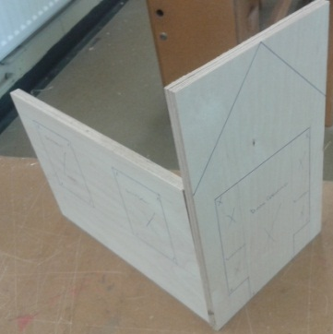
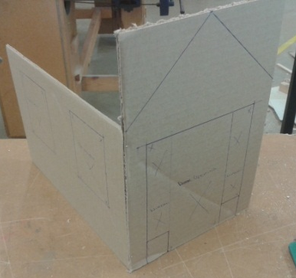
To begin the experiment I have decided to make a small portion of a model… in this case it will be a front porch of a house (just two adjoining walls). These have been marked out 3 times in the materials outlined above see pictures attached. To make the model more re-life, window, door opening and gable end are marked out it is my hope to also cut these out to so if I come across problems maybe I can take something from it.
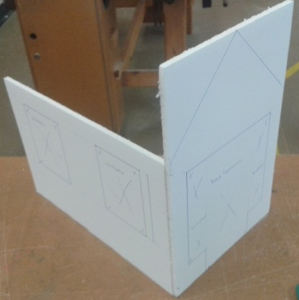

This is only a portion of the model as it is only an experiment and additionally it would be too time consuming as this has to be marked out three times (very repetitive). It is important to note that all 3 were simple to mark out and there were no real advantages/disadvantages of using one or other material whilst carrying out this particular element of work.

Procedure
Mark out all 3 experiments using the materials as listed
Key points to identify
- Abilty to work with material
- Difficulties arising
- Timing of each tasks
- Cost of Materials
- Weight/Distribution/Storage
- Joining Materials
- Painting/Finishing

Use of Tools/ Equipment
Cutting Knife (Cardboard & Foamcore Board)
Cutting Mat (Cardboard & Foamcore Board)
Jig Saw (Plywood)
Bandsaw (Plywood)
Pillar Drill (Plywood)

Results
All 3 materials have been marked out identical but due to their nature have to be practically cut out differently. This was a key problem using plywood through-out; this also becomes a skill set that I would be expected to have regardless of undertaking woodwork at JC level. This could be problem as even other students who have used power tools need to become quite good as window and door openings require lots of freehand lines to be cut using a jigsaw see pictures next page… Drilling the hole was a much more straightforward process.
The cardboard and Foamcore board proved to less labour intensive and also less reliant in getting a particular size as they come in A1 size sheets which I could cut all my piece from therefore not always relying on the teacher to cut me a piece.

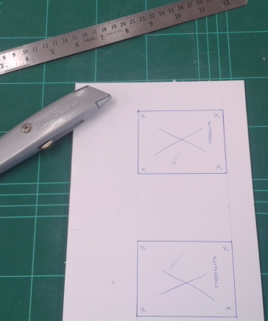
Red lines exaggerating where all freehand cuts would have to be produced to such a high standard in case where I had to join say door & window frames without breakout…. This I think might have been taken for granted as something you might be expected to do very easily… however it is only until you try it you realise you could be making quite a lot of more work for yourself (and remember this is only a section of a proposed model) you could have anything up to 10 windows and maybe anything up to 2 door openings. However when cutting the foamcore board the task is seriously easier and less time consuming and therefore more counterproductive overall.

Conclusion and evaluation of results
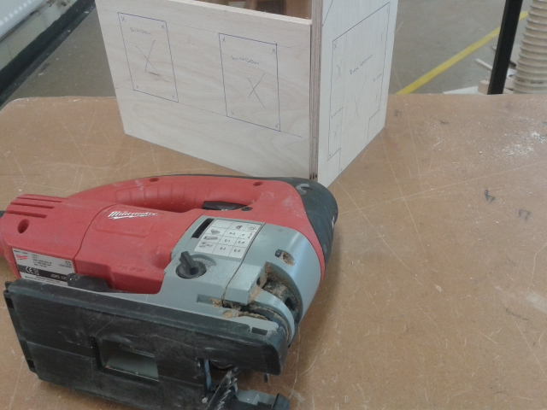
The result were fairly conclusive once I managed the time accurately to complete the same job; but with different materials
The Plywood was very labour intensive and needed a lot of skill to ensure pieces were cut accurately, neatly (not easy to avoid breakout) and finish to a high standard. However probably two things struck me as an disadvantage using this material were, how easily I could make a mistake and the time spent to rectify it and how reliant on the teacher I was for additional pieces. The plywood was also not so straightforward to join to another piece and again no way of sticking it together in a temporary basis. I had to make sure everything was perfect and even with that had to attach battens onto each adjoining piece (something that take more time).

The Cardboard and Foamcore Board were pretty much the same in terms of working with the material. However availability of the same type cardboard could not be guaranteed and size available to me were also an issue. The biggest obstacle for me in using cardboard was it was not that strong once other components were added, rafters, windows, door etc etc and the artefact become less robust as I used it over time.
The foamcore board is a pretty fool proof material quite enjoyable to work with and is available in decent sizes and not so reliant on the teacher to prepare pieces for me. If I made a mistake it was not the end of the world I could easily remark out another piece and work away quietly again. This material was easily attached to another piece of foamcore board initially with small pins that were dovetailed to make the artefact more sound and better still easily taken apart from class to class especially if I had to change the shape or maybe make a cut into the material at a later date.

Comments
This experiment was definitely well worth undertaking, as I would never have imagined what level of understanding I would have gained into picking/choosing materials and the workability of each. It just goes to show that assuming using plywood as a given material could have unearthed so many other complications through-out and in fact could have had a real negative influence on my approach to undertaking my project. I quite enjoyed the simplistic use of both foamcore board and cardboard and in fact I would highly recommend using the foamcore board for the actual project but suggest to use an initial model (mock up) made from cardboard. This will hopefully gain some knowledge as to how I could improve things like form, function, scale, proportion etc… and overall bring a little life to the overall model.

