Chapter Two

Planning of Project

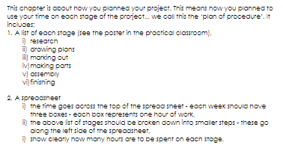

Design an Appropriate Plan of Project:

Evidence of Research:

Working Drawings:

Model/Mock Up:

